Game Design Document Group 7

The Book of Theseus:

A Greek Dungeon Crawling Experience

Copyright @ 2021 by CSC 227 Group 7

Written by Peter Cruciata

Version # 0.1

Table of Contents

Design History 3

Game Overview 4-6

Gameplay and Mechanics 7-10

Story, Setting and Characters 11-16

Levels 17-18

Interface 19

Artificial Intelligence 20

Technical 21

Game Art 22-26

Management 27

Appendices 28-35

Design History

Version 0.1.1

This is the first iteration of the game. In this state the game is playable. A temporary player character is walking around a primitively designed dungeon area. The player is able to interact with items and enemies. However currently there is no goals set for the player to accomplish.

Version 0.1.2

In this version of the game scenes were being designed in a rudimentary design with enemies walking towards the enemy

Version 0.1.3

Player character was updated into Theseus and attacking animations were added. Player was able to kill enemies on screen.

Version 0.1.4

More chambers were being built and the gorgon was added.

Version 0.1.5

Intro screens, loss screens and win screens were made.

Version 0.1.6

Screens were transitioned into one another and boss room was added. Minotaur added as boss.

Game Overview

Game Concept:

The concept of the game is a dungeon crawling adventure. The game is played in a top-down perspective where you progress through a map of an underground interconnecting dungeon. Your goal is to progress through the dungeon and exit while traversing harmful terrain and enemies.

Feature Set:

Player Character will be able to walk in all cardinal directions, but will have to obey laws of physics. (Will not be able to walk through objects or fly). They player will be allowed to collect items whether collectable of power ups. The player will be able to enter combat with the enemies they come across they will have a weapon in which they can defend themselves with. The player wins when the escape the dungeon the player loses upon being defeated by the enemies.

Genre:

The genre of the game is action adventure.

Target Audience:

The game is targeted to reach a wide range of people. We intend for the game to be played and enjoyed by everyone.

Game Flow:

The game is intended to be a dungeon so it will be framed in one room at a time with a linear path. The player will move from room to room fighting enemies to make it out the other side. Every room will have enemies in them and must be completed. The player will have to fight the final boss in order to escape the labyrinth. The goal of the game is quite linear, move from room to room defeat enemies and escape. The game is in a top-down perspective so the room will be framed in the entire shot. Everything in the room will be visible so they player will have a clear scope of what needs to be done.

Look and Feel:

The game is set to be in an underground dungeon with enemies based on mythological monsters. The setting of the dungeon is meant to be murky and dirty. The goal is to make the player feel like they are lost in a hopeless underground that has not been frequented in a long time. The need to escape is meant to feel imminent.

Project Scope:

Number of Locations:

Number of Levels:

Number of NPCs:

There will be four NPC enemies, three basic enemies and a boss.

Number of Weapons:

The player will spawn in the game with a single weapon. This will be his primary use of attack; it is a spear and it will kill basic monsters in one hit.

Gameplay and Mechanics

Gameplay

Game Progression:

Mission / Challenge Structure:

There are no missions to the game. As it is a single level with branching rooms, they challenge comes from beating the enemies and progressing through the room to find they key.

Puzzle Structure:

Objectives:

The objective is to escape the dungeon without being defeated by the enemies. You will move room to room and every room will contain these enemies. Your objective is to reach the end room which will contain the final boss. A boss battle will take place and then you will escape the dungeon and win the game.

Play Flow:

The play will be a linear play style in which the final boss room will always be the end goal. The other rooms however just need to be traversed how you go about that is up to you. Enemies do not need to be killed they can just be avoided. The only fight that has to take place is the boss fight.

Mechanics

Physics:

The games universe rules are based on real life. The player character has no special abilities or any special powers. The player can walk in all cardinal directions and use his weapon to attack what is in front of him. The player cannot walk through walls or jump over obstacles within the map.

Movement:

The player character moves at a constant speed and can walk in all cardinal directions. The player can attack while moving and the movement of the game is meant to feel very responsive. Upon letting go of the movement keys the player character is meant to instantly stop. There is no sprinting or jumping.

Objects:

Actions:

Combat:

Combat is simple but the game is totally built around it. The player spawns into the game with a spear and this will be his primary weapon of attack. The player character can attack directly in front of him but the hitbox is a little disjointed giving the player an extended reach as the players weapon is a spear. The three simple enemies do not have attack animations but on hit they will do damage. The final boss also has a weapon and will attack the player using custom attack animations. The player character has 3 hits before he loses and the players health is represented by a heart container at the top of the screen.

Economy:

Screen Flow:

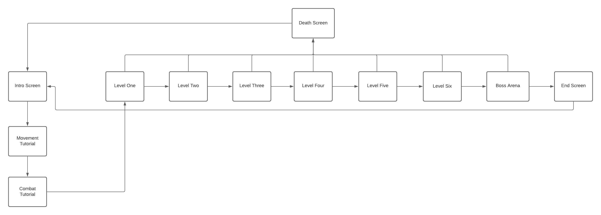

Screen Description:

The intro of the game introduces the title and gives a little insight to the story of the game. The title screen show a piece of Greek pottery and it shows the main character and the final boss, Theseus and the Minotaur. The next two screens are tutorials. One for movement and one for combat. The movement screen explains how movement will work and the buttons needed to be pressed to move. The combat screen does the same explaining the combat mechanics, like attacking and health. Level one through 6 are simple dungeon like rooms. Each room has a unique layout but every room will have a spawn of random enemies that you will need to defeat or avoid to progress to the next room. At any point if you die you will be brought to a death screen. The boss arena is where you will fight the Minotaur. This room also has a unique layout but no other enemies will be in there but the Minotaur. If you beat the Minotaur, you will be brought to the end screen.

Replaying and Saving:

The game has no save function as it is short and meant to be beaten in one run. Replaying comes in the form of beating the game and returning to the title screen and being able to play it again.

Cheats and Easter Eggs:

There are no cheats in the game it is made to be played honestly. Easter eggs, the whole an easter egg to Greek mythology.

Story, Setting and Character

Story and Narrative

Back story:

You are the legendary Greek hero Theseus fighting his way throw the labyrinth to find the and slay the Minotaur. The story is based on the mythological story of the same name.

Plot Elements:

The game is not driven by its story. It is a game that has a backstory only in name and design. However, the setting and final boss does help you get into the mood of the story.

Game Progression:

The game progresses as you make your way through the room. It works in a linear pattern moving through all the rooms to reach the final boss. Every room has to be completed in some form before progressing.

License Considerations:

For the story and characters no licensing would be needed. The likeness of these characters dates back thousands of years and would be considered open source.

Cutscenes:

Game World:

General look and feel of the world:

The world is based on the ancient Greek labyrinth. We designed the levels to look dingy and like an old forgotten dungeon. It uses grays and browns to represent an underground cave kind of feel.

Area 1:

All the levels will take place in the one area of the labyrinth. The labyrinth we created is an underground gray dungeon with multiple rooms. Each room may be designed differently with different enemies being spawned in and different floor layouts. However, they are wholly going to be similar with changes just coming from placement of walls and doors.

Characters:

Character #1:

Player character is Theseus the Greek hero. You take over playing the character on his adventures through the labyrinth.

Personality:

Theseus has no personal characteristics he has no emotions or motivations he is an empty slate that the player can project themselves onto.

Look:

Physical Characteristics:

Theseus is in Greek bronze armor and has a helmet with a blue haired crest on it.

Animations:

Theseus can walk in all the cardinal directions and he can thrust his spear forward to stab an enemy. All of the moves are animated entirely.

Special Abilities:

Relevance to game story:

Theseus is the main character of the story. This is based on his myth of traversing the labyrinth. The game is meant to replicate his time looking and defeating the Minotaur.

Relationships to the other characters:

All the other characters in the game are generic monsters you would find in Greek mythology bats, cyclops, and gorgons. They have no direct relation to Theseus; the minotaur is the only one with direct relation to him. The Minotaur was the antagonist of the myth as he was found at the end of the labyrinth.

Statistics:

Character #2:

The bat is a generic enemy.

Personality:

Look:

Physical Characteristics:

The bat is an oversized bat.  
Animations:

Special Abilities:

Relevance to Game Story

The bats’ purpose in the story is to serve as an obstacle for Theseus to cross as he makes his way through the labyrinth.

Relationships to other characters:

Statistics:

Character #3:

The cyclops is another generic enemy.

Personality:

Look:

Physical Characteristics:

The cyclops is a hulking monster with one eye.  
Animations:

Special Abilities:

Relevance to Game Story

The cyclops’ purpose in the story is to serve as an obstacle for Theseus to cross as he makes his way through the labyrinth.

Relationships to other characters:

Statistics:

Character #4:

The gorgon is the last generic enemy.

Personality:

Look:

Physical Characteristics:

The gorgon is a half woman half snake with snakes for hair.   
Animations:

Special Abilities:

Relevance to Game Story

The gorgons’ purpose in the story is to serve as an obstacle for Theseus to cross as he makes his way through the labyrinth.

Relationships to other characters:

Statistics:

Character #5:

The minotaur is the final boss of the game. He guards the exit to the labyrinth.

Personality:

Look:

Physical Characteristics:

The minotaur is a half man half bull creature. He has a tuft of black fur around his neck and he wields a big hammer. The hammer is made of gold.  
Animations:

The minotaur can swing his hammer out in front of him in an arching motion. The minotaur can also preform an overhead slam with the hammer. These are both attacking animations

Special Abilities:

Relevance to Game Story:

The minotaur is the main antagonist of our adventure he will be the final boss we face.

Relationships to other characters:

The minotaur is directly related to Theseus as they both come from the same myth.

Statistics:

Levels

Level 1:

Synopsis:

The level is broken up into six individual chambers and then a final boss chamber. The first six chambers have enemies spawn in and you need to defeat or pass them in order to progress to the next chamber. Once you leave the sixth chamber you will enter the boss arena in which you will fight the minotaur. If you win you complete the game.

Introductory Material:

The mission is introduced by the two tutorial chambers, they will show you the mechanics of the game.

Objectives:

The objective is to defeat enemies and make it to the next chamber and eventually defeat the boss.

Physical Description:

The chambers are big open rooms with structures in the middle that may provide obstacles. The ground is a gray floor meant to look like a cave floor and the walls are cobblestone like.

Map:

Critical Path:

The game is operated in a linear path so the critical path will have you progress through each chamber in order. Tutorial Movement, Tutorial Combat, room one, two, three, four, five, six, and then the boss arena. Every objective needs to be completed in order to progress.

Encounters:

The player can encounter any of the basic enemies in chambers one through six. The basic enemies are bat, cyclops, and gorgon. In the final boss room, the minotaur will appear and he will be your last fight.

Level Walkthrough:

Closing Material:

After you beat the minotaur you will get a victory screen, this is the end of the game and you have won. At any point during playing however, if you die you will be brought to a game over screen and then back to the main menu.

Training Level:

The training levels are the two first chambers that introduce the game. The first chamber is a movement tutorial. Here we explain the movement and how to move. Combat tutorial is in the second chamber. Here we explain how fighting the enemies works.

Interface

Visual System:

Control System:

The player controls the game by using the WASD buttons or the arrow keys to move. You attack with the left mouse button. While walking you can press the LMB to attack.

Audio:

Music:

Suonho_ScaryScape_01.wav by suonho – Intro Music

<https://freesound.org/people/suonho/sounds/9695/>

Shadow of the Colossus: The Opened Way by Kow Otani – Victory Screen <https://www.youtube.com/watch?v=eYHFSXp1mH4&t=14s>

The Elder Scrolls V: Skyrim-Beneath the Ice by Jeremy Soule- Background Music

<https://www.youtube.com/watch?v=FOQc_WyDejg>

Sound Effects:

Sword Attack by Saviraz – Intro Music

<https://freesound.org/people/Saviraz/sounds/547600/>

Necro- nooooooo Fsh.mp3 by ludist – enemy groans

https://freesound.org/people/ludist/sounds/204459/

Help Systems:

Artificial Intelligence

Opponent AI:

Enemy AI:

Enemies walk towards the player. But will not take any specific path. The bat, gorgon, and cyclops do not have any attacking animations so once they reach the player, they will do damage on collision. The minotaur AI is a little more advanced as it will randomly cycle through its attacking animations.

Non-combat Characters:

Friendly Characters:

Support AI:

Player and Collision Detection:

The player collision stops the player from walking through walls and structures. The player hitbox can collide with the enemy hit box. If the players attacking hitbox enters the enemies hurt box, on collision the enemy will be destroyed. If the enemy hit box collides with the player hurt box the player will take damage. The players attacking hit box is disjointed from his character model allowing him to attack without the enemies entering the hurt box.

Pathfinding:

The enemies will path towards the player but no specific pathing instructions are given

Technical

Target Hardware:

The game is targeted towards all types of systems. It isn’t too demanding technically and should be able to run on most systems.

Development Hardware and Software:

The software used to develop this game was C# and unity. Unity was used for map layouts and hitboxes and prefabs along with scene construction. C# was used to create the scripts for the enemy and player characters.

Development procedures and Standards:

Game Engine:

Network:

Scripting Language:

C#

Game Art

Concept Art:

Style Guides:

Characters:

Theseus:

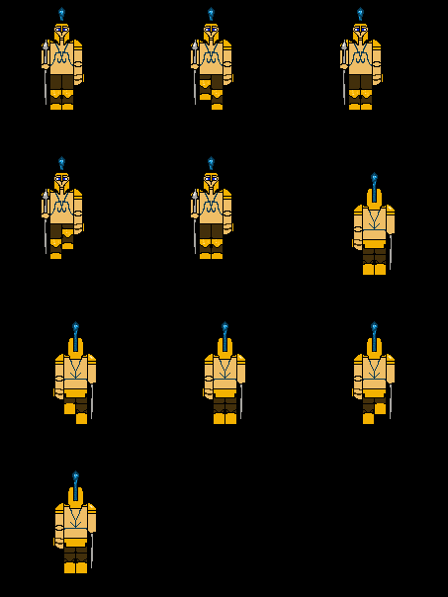

Bat:

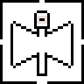

Cyclops:

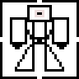

Gorgon:

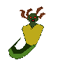

The Minotaur:

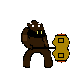

Environments:

Slim Brick Wall:

Small Slim Break Wall:

Door:

Equipment:

Cut Scenes:

Intro Screen:

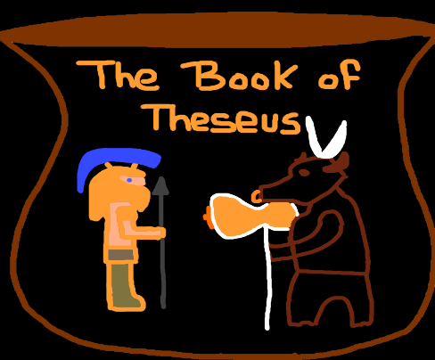

Death Screen 1:

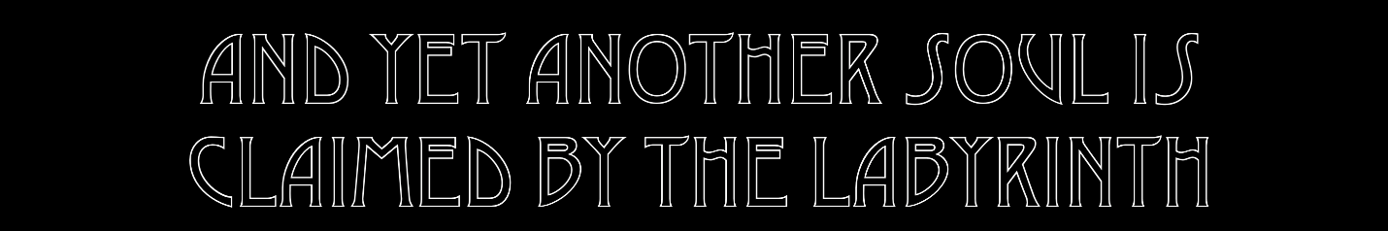

Death Screen 2:



Death Screen 3:



Victory Screen 1:



Victory Screen 2:

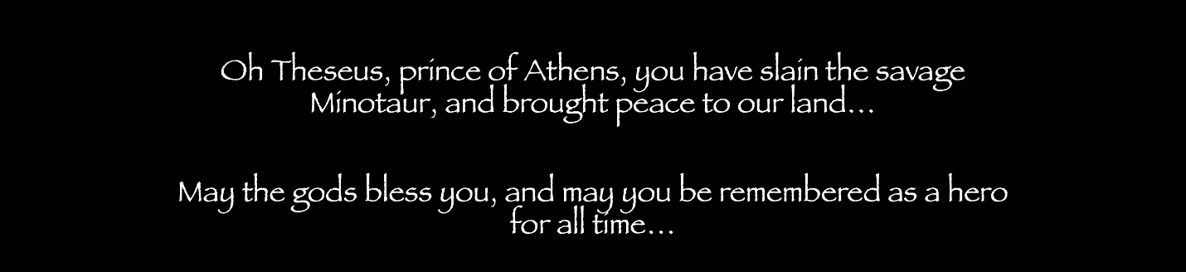

Misc:

Heart Containers:

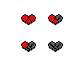

Management

Detailed Schedule:

Work Log Document

Budget:

Risk Analysis:

Localization Plan:

Test Plan:

Appendices

Model and Texture List:

Thin Wall:



Thick Wall:



Door:



Background Scene:



Animations List:

Theseus Walking:

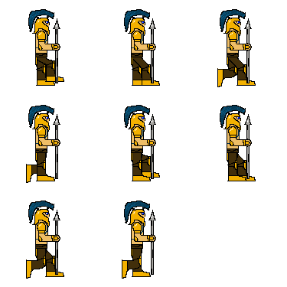

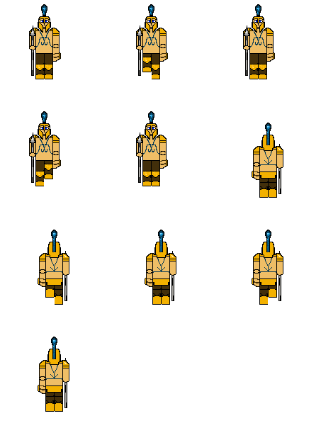

Theseus Stabbing:

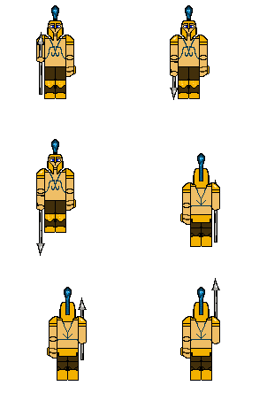

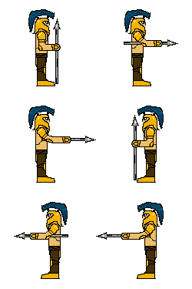

Death Animation:

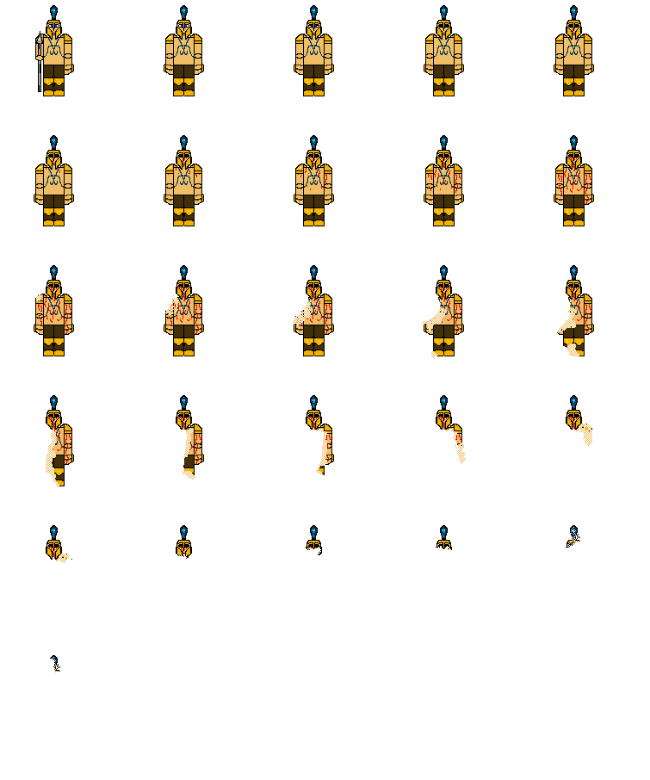

Victory Pose:

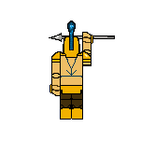

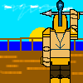

Minotaur Overhead Attack:

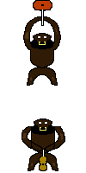

Minotaur Side Swing Attack:

